CRU Cable Conference makes in-person comeback after three years
2 Aug 2022
Natalie Noor-Drugan, Editor in Chief
Delegates at the recent CRU Wire & Cable Conference were delighted to see each other again after nearly three years since the last face to face conference. CRU had successfully run virtual conferences in 2020 and 2021 due to the pandemic, but nothing beats seeing everyone in the room together, having coffee and tea or sitting down to lunch together, particularly at a cosy venue like the Sofitel London St James.

The mood at the conference was upbeat, with cable equipment manufacturers saying that demand from cable producers was ‘through the roof’, while many cable producers said that they were posting some of their strongest results ever. The main reasons for this are higher metals prices, particularly over FY 2021 and strong demand from sectors benefitting from megatrends like renewables, grid strengthening, enhancement and expansion, automation, 5G, datacentre expansion, and FTTH buildouts, amongst others.

Hotly debated and talked about in various sessions were the topics of energy security, rising energy prices, labour shortages, logistical bottlenecks, component shortages, rising inflation and the impact of political decisions by various countries on the wire and cable industry.
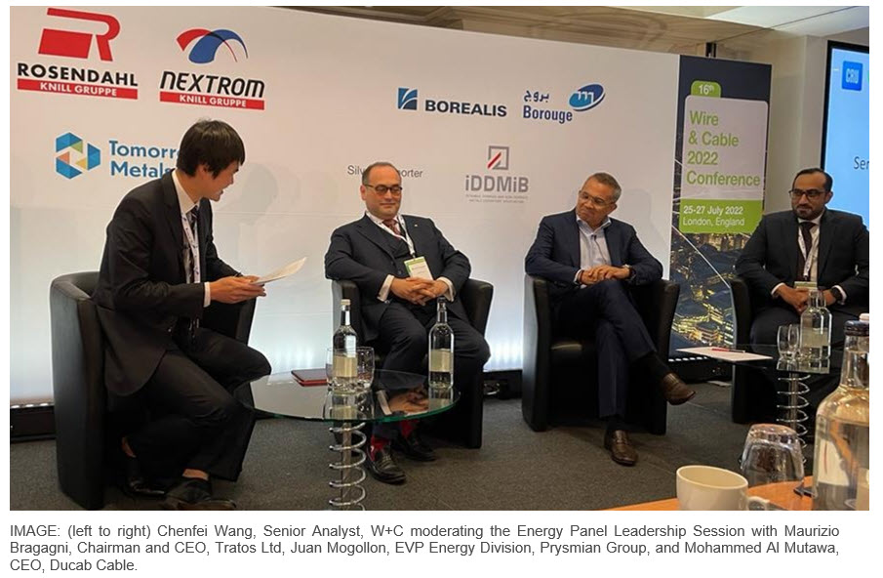

Various CRU analysts provided their take on these issues: Aisling Hubert, CRU W+C Analyst, provided CRU’s outlook for metallic insulated cable demand in various regions, while Michael Finch, Head of W+C and Chenfei Wang, Senior Analyst, W+C, outlined CRU’s outlook and drivers for fibre optic cable global cable demand. CRU analysts Zaid Aljanabi, Head of Aluminium, Consulting, and Piotr Kulas, Senior Analyst Value Creation, Base Metals, talked about the issues affecting future aluminium and copper markets while CRU economist Filippos Papasavvas explained the impact of inflation on CRU’s macroeconomic outlook.

Southwire’s Charlie Murrah, EVP and Chief Supply Chain Officer offered an interesting producer perspective on the situation in North America. Murrah explained how the energy transition, geopolitical influences, new post Covid work situations are affecting the company’s product development, hiring practices and operations.

On the first day of the conference, there were two leadership panels, one for energy cables and another for fibre optic cables. In the energy cables panel, Juan Mogollon, EVP Energy Division, Prysmian Group; Maurizio Bragagni, Chairman and CEO, Tratos Ltd; and Mohammed Al Mutawa, CEO, Ducab Cable discussed the impact of the war in Ukraine, Russian sanctions, Covid-19, and rising energy prices on elements of their business.

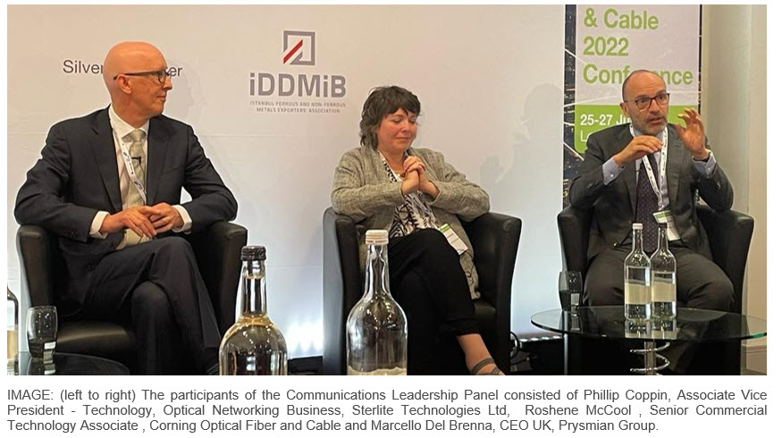

The Communications Leadership Panel was slightly more technical with Marcello Del Brenna, CEO UK, Prysmian Group; Roshene McCool, Senior Commercial Technology Associate, Corning Optical Fiber and Cable; and Phillip Coppin, Associate Vice President - Technology, Optical Networking Business, Sterlite Technologies Ltd revealing current 5G and FTTx deployment trends, and which regional markets or product types may hold new opportunities.

Sustainability was another topic discussed at the conference with Paul Keller, Business Growth Manager Low Voltage/ Flame Retardant, Borealis Polymers Oy; Roland Montagne , Principal Analyst, Broadband & FTTx, IDATE DigiWorld; and Tanja Winter, Head of Marketing & Sales Rod, Aurubis AG and Kirsten Kück, Sustainability Manager, Aurubis providing their take on what sustainability looks like for their respective business fields.

